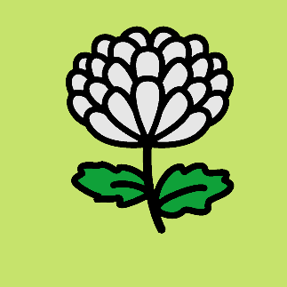
APPLICATION FOR MEMBERSHIP
WA Chrysanthemum Society

Please E-mail completed forms to: chrysiewa@gmail.com
Name:
Address:
Home Phone:
Mobile:
Email:

I consent to being added to the mailing for all WACS information and newsletters (you can unsubscribe at any time)

Single Membership is $10 OR Double Membership is $15

EFT payment can be made to our Bank account, details for this are:

BSB - 036 – 069
ACCOUNT – 326644

Please make sure you put your name in the payment details.

OR We can send you credit card payment link

If you have any queries about applying for membership please contact the Treasurer, Colleen Ryall ph: 0400 048 223

Membership application will be approved and ratified at the next WACS Committee Meeting

