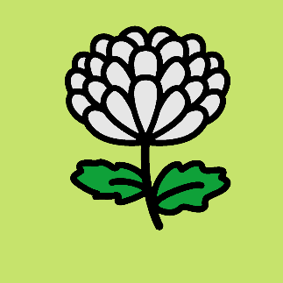
APPLICATION FOR MEMBERSHIP
WA Chrysanthemum Society

Please E-mail completed forms to: chrysiewa@gmail.com
Name:
Address:
Home Phone:
Mobile:
Email:

I consent to being added to the mailing for all WACS information and newsletters (you can unsubscribe at any time)

Single Membership is $10 OR Double Membership is $15

EFT payment can be made to our Bank account, details for this are:

BSB - 036 – 069
ACCOUNT – 326644

Please make sure you put your name in the payment details.

OR We can send you a credit card payment link

If you have any queries about applying for membership please contact the Treasurer, Colleen Ryall ph: 0400 089 223

Membership application will be approved and ratified at the next WACS Committee Meeting

